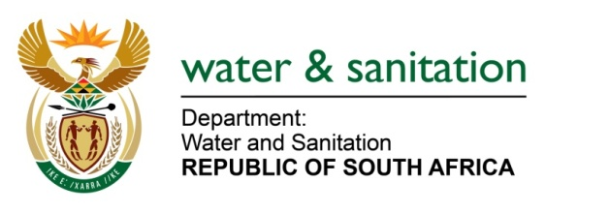

NATIONAL GROUNDWATER STRATEGY
MULTI-SECTOR PROVINCIAL WORKSHOPS-REGISTRATION SHEET

Name: ......................................................................................................................................
Surname: ..........................................................................................................................
Sector (tick): DWS Agriculture Local government Industry Energy
Mining Other (please specify, e.g Academia):......................................................

Organization:..............................................................................................................................
Position in organization:.............................................................................................................
Tel:...............................................................Email......................................................................
Regional Workshops and dates (Please choose from the table below)
Province | Town | Workshop date | Revised Workshop date | Please TICK ()
Gauteng | Pretoria | 04 May 2016 | 04 May 2016
Free State | Bloemfontein | 09 June 2016 | 20 July 2016
North West | Rustenburg | 07 June 2016 | 21 July 2016
Eastern Cape | Port Elizabeth | 24 May 2016 | 26 July 2016
KwaZulu-Natal | Durban | 02 June 2016 | 27 July 2016
Limpopo | Polokwane | 31 May 2016 | 11 August 2016
Western Cape | Bellville | 25 May 2016 | 16 August 2016
Mpumalanga | Mbombela | 14 June 2016 | 18 August 2016
Northern Cape | Upington | 22 June 2016 | 23 August 2016

Special Dietary Requirements................................................................................................
Please email Workshops-Registration Sheet to NGS@dws.gov.za

